- A file descriptor (FD) is simply an integer number that the operating system gives to a process when it opens something.
- The operating system assigns the lowest available file descriptor number when you open a resource.
Think of it as a ticket number.
Suppose you tell Linux:
Open student.txt
Linux may say:
Okay, I will give you ticket number 3.
So:
Student.txt —-> FD3
Your program doesn't have to keep saying "student.txt" every time.
It can simply say FD 3 to refer to that open file.
Similarly, Linux gives your program a number:
File → File Descriptor
For example: student.txt → 3
That number 3 is the file descriptor.
Every normal process starts with three standard file descriptors:
0 → Standard Input
1 → Standard Output
2 → Standard Error

0 → stdin → Where do I GET input?
1 → stdout → Where do I SEND normal output?
2 → stderr → Where do I SEND error output?
We normally write them as:
STDIN_FILENO
STDOUT_FILENO
STDERR_FILENO

Number | Name | Meaning
0 | STDIN_FILENO | Input
1 | STDOUT_FILENO | Output
2 | STDERR_FILENO | Error output

Program 1: stdout — Standard Output
#include <unistd.h>
int main()
{
write(STDOUT_FILENO, "Hello World\n", 12);
return 0;
}
Output:
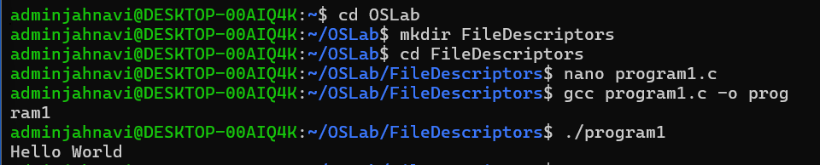

Program 2: stdin — Standard Input
#include <unistd.h>
int main()
{
char buffer[20];
read(STDIN_FILENO, buffer, sizeof(buffer));
write(STDOUT_FILENO, buffer, sizeof(buffer));
return 0;
}
Output
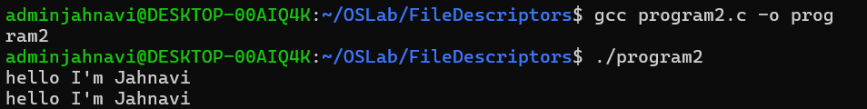
Program 3: Proper stdin + stdout
#include <stdio.h>
#include <unistd.h>
int main()
{
char buffer[100];
int n;
printf("Enter something: ");
n = read(STDIN_FILENO, buffer, sizeof(buffer) - 1);
if (n > 0)
{
buffer[n] = '\0';
write(STDOUT_FILENO, buffer, n);
}
return 0;
}
Output
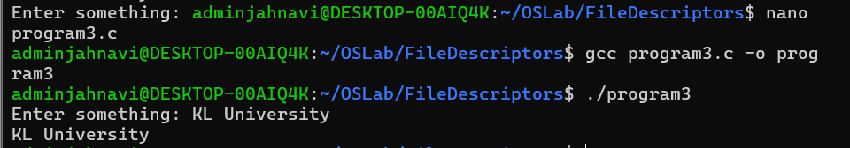

Program 4: stderr — Standard Error
#include <unistd.h>
int main()
{
write(STDERR_FILENO, "This is an error\n", 17);
return 0;
}

As STDERR_FILENO is: 2
write(STDERR_FILENO, "This is an error\n", 17) is equivalent to:
write(2, "This is an error\n", 17);
You will see output as: This is an error.
Output
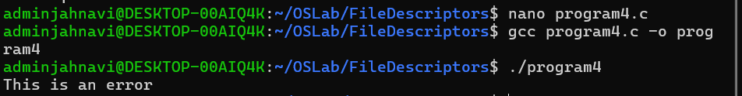
Program 5: stderr for an Actual Error
#include <stdio.h>
#include <fcntl.h>
#include <unistd.h>
int main()
{
int fd;
fd = open("doesnotexist.txt", O_RDONLY);
if (fd == -1)
{
perror("open");
return 1;
}
close(fd);
return 0;
}
Output
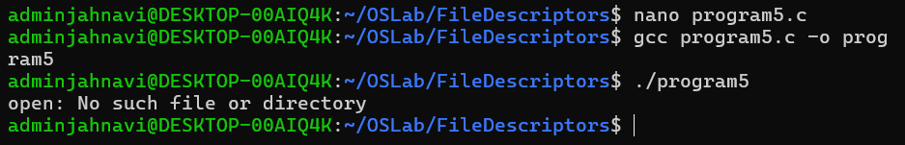
Program 6 Creating file using file descriptor
#include <stdio.h>
#include <fcntl.h>
#include <unistd.h>
int main()
{
int fd;
fd = open("student.txt", O_CREAT | O_WRONLY, 0644);
if (fd == -1)
{
perror("open");
return 1;
}
printf("File created successfully!\n");
printf("File descriptor = %d\n", fd);
close(fd);
return 0;
}
Output
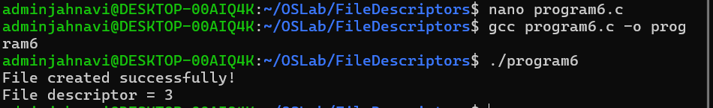
gcc create.c -o create
./create

Output:
File created successfully! File descriptor = 3

fd = open("student.txt", O_CREAT | O_WRONLY, 0644); describes the information below:

"student.txt" → file name
O_CREAT → create if it doesn't exist
O_WRONLY → open for writing
0644 → file permissions
fd → stores the file descriptor

Program 7
#include <stdio.h>
#include <fcntl.h>
#include <unistd.h>
int main()
{
int fd;
fd = open("student.txt", O_WRONLY | O_TRUNC);
if (fd == -1)
{
perror("open");
return 1;
}
write(fd, "New Data\n", 9);
close(fd);
return 0;
}

If a file already has data, O_TRUNC removes all its existing contents when you open it for writing.

First, suppose student.txt contains:

Hello
Welcome
Operating Systems

After open() with O_TRUNC:
Student.txt contains (empty)
Output
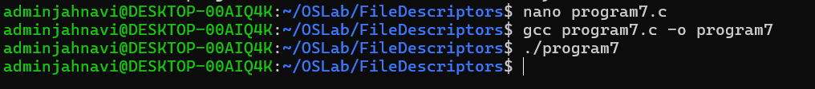
DUP ( ) : duplicate a file descriptor.
dup() creates a new file descriptor that refers to the same underlying open file or I/O resource as the original descriptor.

Suppose:

int fd1 = open("student.txt", O_WRONLY);

If the OS gives:

fd1 = 3

then:

FD 3 → student.txt

Now we do:

int fd2 = dup(fd1);

The OS creates another file descriptor, usually:

fd2 = 4

Now both FD 3 and FD 4 refer to the same open file.

Program 7 - Understand dup()
#include <stdio.h>
#include <fcntl.h>
#include <unistd.h>
int main()
{
int fd1, fd2;
fd1 = open("student.txt", O_CREAT | O_WRONLY, 0644);
if (fd1 == -1)
{
perror("open");
return 1;
}
printf("fd1 = %d\n", fd1);
fd2 = dup(fd1);
printf("fd2 = %d\n", fd2);
close(fd1);
close(fd2);
return 0;
}
Output: fd1 = 3 fd2 = 4

